34th River BLACKWATER CANOEING TOUR – 30th March 2025

--------------------------------------------

The River Blackwater tour from KELVEDON (map ref TL860 180 Post Code **CO59BE**) near Grey's Mill to LANGFORD (map ref TL837 090 Post Code **CM96QA**) is about 13km. with 4 portages around mills on the way.

- IT IS SHALLOW IN PARTS WHEN THERE IS NO RAIN.

- IT CAN BE DANGEROUS IN SPATE.

- CHECK COURSE BRIEFING ON THE DAY.

- ALL ENTRANTS ARE TO ENSURE THEIR PARTY IS CAPABLE of the trip.

This tour has been arranged with all of the landowners. You will be portaging over private property.No other access has been arranged.

**PARK TIDILY BEYOND THE STARTING POINT** at the meeting place.

DO NOT BLOCK THE ROAD – it is surprisingly busy and fast!!

SEE DIAGRAM BELOW plus LOOK FOR THE SIGNS.

The entry to the river will only be via the white rails along the roadside.

**Boats are to be carried to the start point during the car shuttle. Watch out for cars**!

Respect property on the route, leaving the lunch stop area clean and tidy, noting a 400 metre portage, and change discretely in the Langford village hall car park at the end.

Toilet at lunch stop only.

All participants are responsible for their own safety at all times

NO SAFETY COVER IS PROVIDED BY THE ORGANISERS

Carry out your own risk assessments

# Meet time :- 10am Please be prepared to help to shuttle cars

Start time :- 11am sharp at about 10:10am (takes about 45 mins)

## Finish time:- 3:30pm approx. **NO minibus for the shuttle**.

FEES per BOAT…………………..£9:00 (or £7.00 children only) Includes BC fee for insurance

BC member In boat(with card) .....£4:00 (or 2.00 children only) **must be** personal members

In other words there is an extra £5 fee for boats without a BC member aboard.

(Children are welcome with their own full adult supervision)

# **LIMIT :- FIRST 50 TO CONFIRM with all details ONLY**

# **(Remember you are committing to paying the fees when booking)**

Access organiser is M Robards - 01621 817062 e-mail: mjrob45@gmail.com **©2025 M Robards**

Parking at start may have to change slightly

### Finish at Langford

### Start at Kelvedon

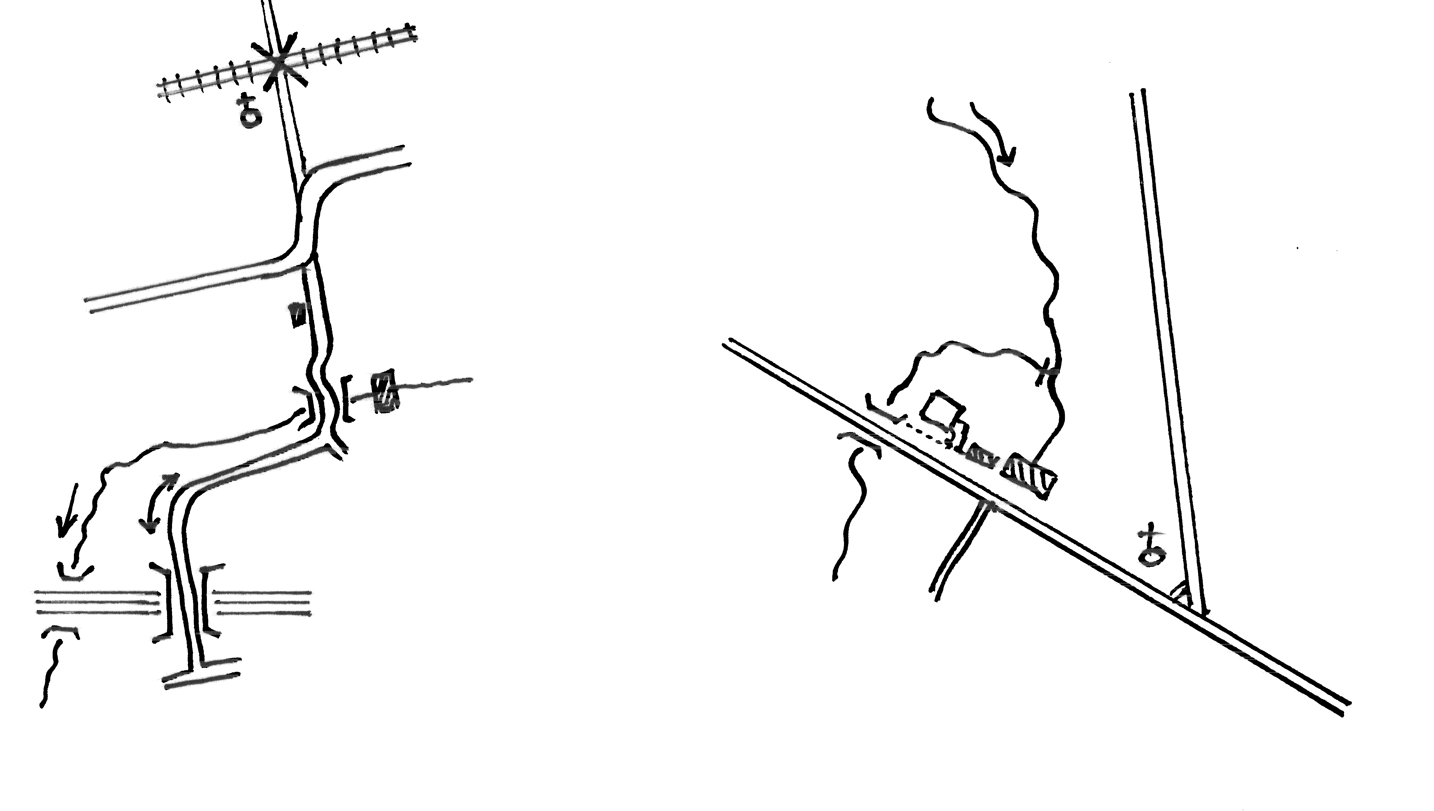

#### No Parking

## Car Park

park carefully on hard area only

Beware - busy road at start

Gt Braxted

Chelmsford

Parking

Golf

Course

Museum of Power

London

**Please park tidily**

Grey’s

Mill

Kelvedon

##### B1024

Railway

**A12** Colchester

##### B1019

##### B1018

Hatfield

Peverel

Maldon

Witham

# **N**

# **N**