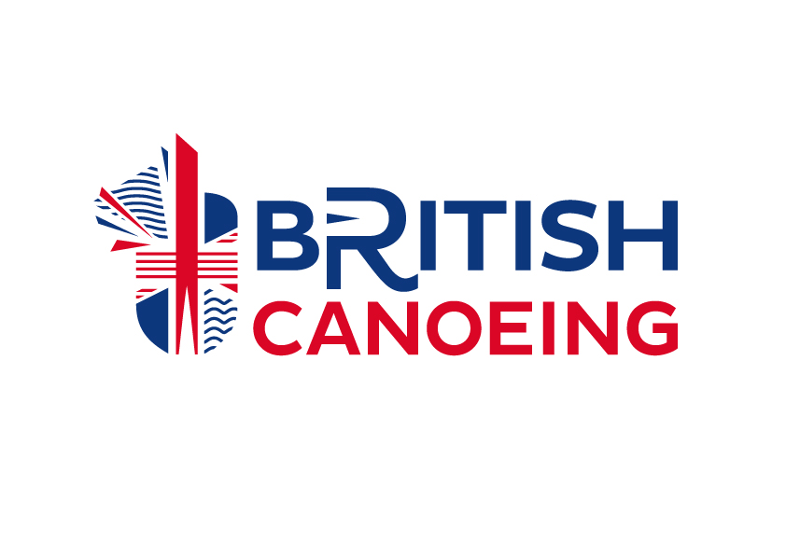

Centre / Club Name: Maldon Canoe Club

What is Sports Equality?
Sports Equality is about fairness in sport; equality of access; recognising inequalities and taking steps to address them. It involves changing the culture and structure of sport to ensure it becomes equally accessible to all members of society and ensuring that everyone has the opportunity to realise their talent and full potential.

Equality Policy Statement
The Club is fully committed to the principles of equality of opportunity and aims to ensure that everyone has a genuine and equal opportunity to participate in Paddlesport at all levels and in all roles of the sport, irrespective of age; disability; gender reassignment; marriage and civil partnership; pregnancy and maternity; race; religion or belief; sex and sexual orientation. In addition, the Club will endeavour to ensure that all are given the same opportunities regardless of their socio-economic background. This includes members, volunteers, participants, supporters, coaches, officials, job applicants and employees (together known as Stakeholders).

The Club recognises that unlawful discrimination is unacceptable and will not tolerate direct or indirect discrimination, whether intentional or unintentional.

The Club will take, or support, positive action to eliminate individual and institutional discrimination:

- The Club respects the rights, dignity and worth of every person and will treat everyone equally within the context of their sport.

- The Club is committed to everyone having the right to enjoy their sport in an environment free from threat of intimidation, victimisation, harassment and abuse.

- All Club members have a responsibility to oppose discriminatory behaviour and promote equality of opportunity and the club’s management committee is responsible for implementing, maintaining and dealing with any breaches of this policy.

- The Club regards any incidence of discriminatory behaviour as serious misconduct and will deal with this according to club disciplinary procedures.

Legal Responsibilities
The Club is required by law not to unlawfully discriminate against its Stakeholders and recognises its legal obligations under, and will abide by the requirements of, the Equality Act 2010, and any equivalent legislation (as amended) in any UK jurisdiction, Jersey, Guernsey or the Isle of Man and any later amendments to such legislation or subsequent equality related legislation that may be relevant to the Club. The Club will seek advice each time this Policy is reviewed to ensure it continues to reflect the current legal framework and good practice.

The Club considers that canoeing is a gender affected sport under the Equality Act 2010 and will adhere to the British Canoeing guidance and policy in relation to participation by transgender athletes. A copy of this policy can be found on the British Canoeing website and any queries should be directed to the Lead Officer for Equality in the first instance.

Implementation
A copy of the policy will be available to all members and employees of The Club. All persons shall respect, act in accordance with, and thereby support and promote the spirit and intentions of this policy.

Reasonable Adjustments
The Club recognises that it has a duty to make reasonable adjustments for people with disabilities. The Club will consider all requests for adjustments and where possible will accommodate reasonable requests and will work with disabled Stakeholders to implement any adjustments that will enable them to participate more fully in all Club activities.

Types of Unlawful Discrimination
The Club regards any form of unlawful discrimination as serious misconduct and any employee, volunteer or member who unlawfully discriminates against, harasses or victimises any other person will be liable to appropriate disciplinary action. Unlawful discrimination can take the following forms:

Direct Discrimination
- treating a person less favourably than others would be treated in the same circumstances on the grounds of age; disability; gender reassignment; marriage and civil partnership; pregnancy and maternity; race; religion or belief; sex and sexual orientation.

Indirect Discrimination
- occurs when a job requirement or condition is applied equally to all, which has a disproportionate and detrimental effect on one sector of society, because fewer from that sector can comply with it and the requirement cannot be justified in relation to the job.

Harassment
- described as inappropriate actions, behaviour, comments or physical contact that are objectionable or cause offence to the recipient or any other individual affected by such conduct.

Bullying
- described as the misuse of power, the act of criticising persistently or to humiliate and undermine an individual’s confidence.

Victimisation
- described as when one person is treated less favourably than others because he or she has taken action under one of the relevant Acts / Regulations or provided information about discrimination, harassment or inappropriate behaviour.

Declaration of Intent:
The Club hereby declares that this policy is adopted by the members and committee of The Club and will implement this policy into the club environment:

Name (print): Clive Marfleet______ Position in Club: __Welfare officer__________________________

Signed on behalf of the Committee: ___Clive Marfleet____ Dated: _08 January 2023______

Clive Marfleet can be contacted on
welfare@maldoncanoeclub.co.uk
07795 508 839

